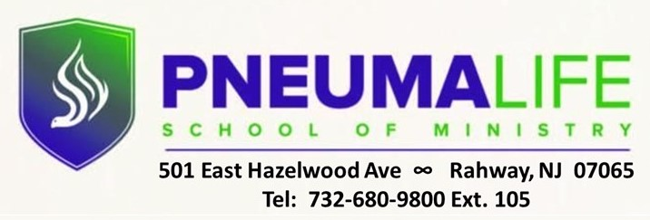

REGISTRATION FORM
(Please populate all boxes and return via email to pneumalifeschool@yahoo.com)

LAST NAME FIRST NAME STUD ID

EMAIL ADDRESS PHONE #

ACADEMIC PROGRAM
FALL 2021 COURSE OFFERINGS AND FEES
SELECT  COURSE | COURSE NAME | COURSE # | DAY | TUITION FEE | REG FEE | BOOK FEE | TOTAL COST
 | LIFE OF CHRIST | DBIB 362 |  | $405. | $35. | $90 | $530.**
 | MINISTRY AND LEADERSHIP DEVELOPMENT | DPRM 333 |  | $405 | $35. | $90 | $530.**
 | SERMON PREPARATION | DPRM 340 |  | $405. | $35. | $65. | $505.**
 | SPIRITUAL ISSUES IN SUBSTANCE ABUSE | DPRM 449 |  | $405. | $35. | $70. | $510.**
 | CHRISTIAN FAITH AND MINISTRY | DTHE 230 |  | $405 | $35. | $65. | $505.**
 | BIBLE DOCTRINE II | DTHE 314 |  | $405. | $35. | $75. | $515.**
 | MINISTRY PRACTICUM | DPRM 320 |  | $135. | $35. |  | $170.

Please place an “X” next to desired course. Fees should be paid before first night of instruction.
** ADDITIONAL $50. ONE-TIME APPLICATION FEE REQUIRED FOR ALL FIRST-TIME STUDENTS

$
____________________________________ AMOUNT PAID
Student Signature / Date

To make a payment, please cut and paste the link below and enter the amount of payment:
https://checkout.square.site/merchant/5VR6CPB1PRY85/checkout/Q6TGI6QXIXRLQBZQ6WRTV3AC

For Office Use Only

TOTAL AMOUNT DUE: $ _________________
APPROVED: REGISTRAR

____________________________________________
DATE | AMT PAID | BALANCE

