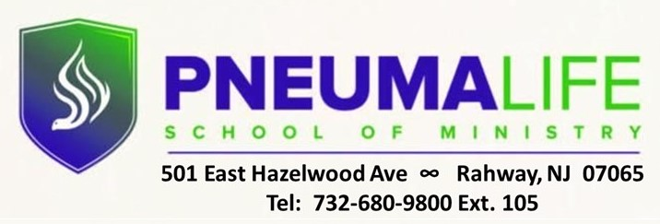

REGISTRATION FORM
(Please populate all boxes and return via email to pneumalifeschool@yahoo.com)

LAST NAME FIRST NAME STUD ID

EMAIL ADDRESS PHONE #

ACADEMIC PROGRAM
SPRING SEMESTER 2022 COURSE OFFERINGS AND FEES
SELECT COURSE | COURSE NAME | COURSE # | TUITION FEE | REG FEE | BOOK FEE | TOTAL COST
 | HISTORY OF CHRISTIANITY II | DTHE 454 | $405 | $35. | $60. | $500.**
 | MAJOR WORLD RELIGIONS | DTHE 303 | $405 | $35. | $80. | $520.**
 | OLD TESTAMENT | DBIB 110 | $405 | $35. | $80. | $520.**
 | POETIC LITERATURE | DBIB 457 | $405 | $35. | $70. | $510.**
 | SERMON PREPARATION | DPRM 340 | $405 | $35. | $65. | $505.**
 | SPIRITUAL ISSUES IN SUBSTANCE ABUSE | DPRM 340 | $405 | $35. | $70. | $510.**
 | MINISTRY PRACTICUM | DPRM 320 | $135. | $35. |  | $170.

Please place an “X” next to desired course. Fees should be paid before first night of instruction.
** ADDITIONAL $50. ONE-TIME APPLICATION FEE REQUIRED FOR ALL FIRST-TIME STUDENTS

$

AMOUNT PAID
Student Signature** / Date
**TYPED NAME CONSTITUTES VALID SIGNATURE

To make a payment, please cut and paste the link below and enter the amount of payment:
https://square.link/u/fr9BzYJu

For Office Use Only

TOTAL AMOUNT DUE: $ ____________________
APPROVED: REGISTRAR

____________________________________________
DATE | AMT PAID | BALANCE

